

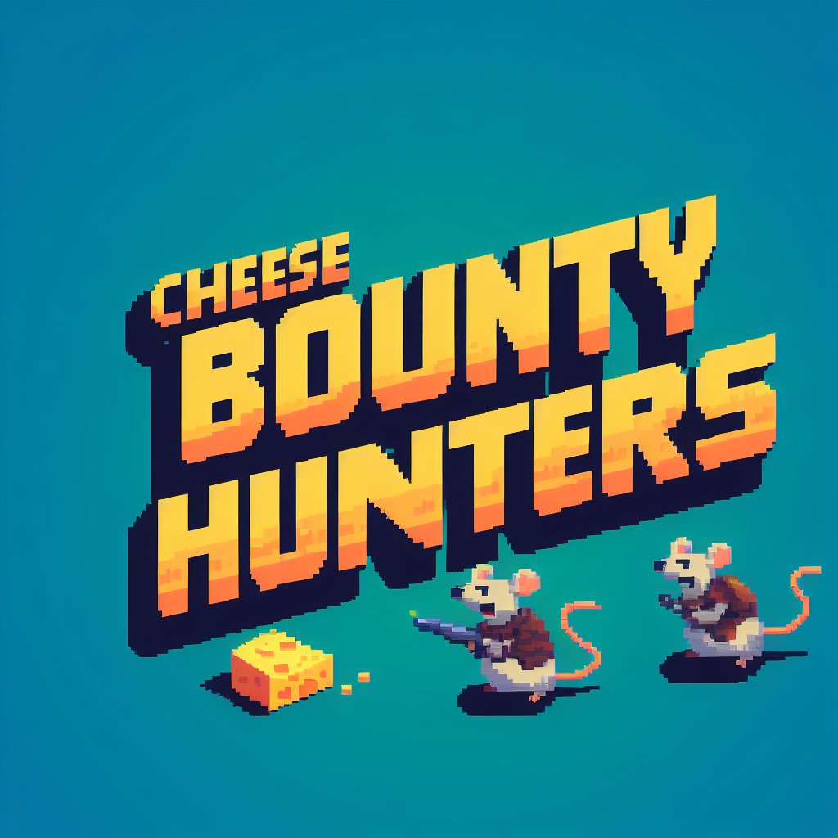





**Game Analysis 3**

**Mission Statement 3**

**Genre 3**

**Platforms 3**

**Target Audience 3**

**Storyline & Characters 4**

**Gameplay 5**

**Overview of Gameplay 5**

**Player Experience 5**

**Gameplay Guidelines 5**

**Game Objectives & Rewards 5**

**Gameplay Mechanics 6**

**Level Design 7**

**Control Scheme 7**

**Game Aesthetics & User Interface 8-12**

# Game Analysis

Ever Wanted to Kill Evil Cat Zombies and save the world from an apocalypse? Now you can! play as Dice and Slice, the epic rat agents brothers and collect special Cheese after each level and give it to Professor Cheddar to end the zombie cat apocalypse once and for all!

# Mission Statement

If you are looking for a high action indie platformer and lots of cheese, Cheese Bounty Hunters is for you! Swap between Dice and Slice, a combination of tankiness and swiftness to destroy the cat zombies, acquire special cheese and save the world.

# Genre

Platformer

Run & Gun

Indie

# Platforms

PC

# Target Audience

This game’s target audience are players who like the story of a zombie apocalypse and enjoy 2D platformers and shotters. Players who feel like saving the world and don't like cats should pick this game immediately, of course, if you are a cat person, maybe the game isn't for you and the game does include violence, but not so violent that the game has to be restricted to adults only. The game is for players ages 10 and up.

# Storyline & Characters

In Cheese Bounty Hunters’ world, a cat zombie apocalypse has begun, and the rats are in grave danger. You play and follow the story of two rat brothers who try to collect special cheese for Professor Cheddar (their uncle) to make a cure for the cat zombie apocalypse and avenge their dead father - Caciocavallo. Along the way, Slice, the fast blade user and Dice, the tanky shield defender, form a new point of view on the world but also on themselves as brothers.

| Character | Description | Characteristics | Misc. Info |
| --- | --- | --- | --- |
| Dice | Dice is smart and calm, he is the big brother in the duo that is Dice and Slice, he is one of the playable character in the game | Dice cares a lot about Slice.  Dice defends the player and Slice with his tanky and trusty shield from cat zombies who use ranged attacks. He Can’t use the shield forever though. | Son of Caciocavallo.  He Hates olives. |
| Slice | Slice is silly and cool most of the time, but he has a big heart. He is the second playable character. | Slice finds his brother as annoying and a nerd but is amazed by his shield a lot. Slice uses a special blade to cut cat zombies who get too close. | Son of Caciocavallo.  He loves olives. |
| Professor Cheddar | Professor Cheddar takes care of the brothers Caciocavallo left behind and ensures them that he can save the world with their help. Cheddar is not playable, but can upgrade the brothers tools | Professor Cheddar will appear after each level and can help Slice and Dice by upgrading their tools. Cheddar is a science freak so every chance he gets to work on something he is delighted. | Brother of Caciocavallo. |

# Gameplay

## Overview of Gameplay

This game takes a lot of inspiration from Super Mario World with its platforming and Cuphead with its many enemies on each level with a unique twist of swapping between the two characters, Slice and Dice. The game has only one game mode and that is story mode where you play as Slice and Dice as they try to save the world.

## Player Experience

You start at a bonker in a forest getting armed and ready for the first outing since the apocalypse broke out trying to get all the way back to the main city and reach the cheese factory where the last special cheese is hidden. On your way there, you go through many cat zombies who get stronger and fearsome. The more you progress, the weirder and more eerie places seem to be.

## Gameplay Guidelines

In Cheese Bounty Hunters, you play as Slice and Dice while swapping between the two, however, you cannot play them at the same time, the player should engage in optimizing when to swap to each character making this mechanics and each rat’s play style feel more dynamic and fun. While violence is included in the game, swearing isn’t since Slice and Dice just don’t enjoy curse words.

## Game Objectives & Rewards

The player should focus on maximizing zombie cats kills while also saving time. Rewarding him with the most points in each level to get greater upgrades for Slice and Dice’s weapons. However he should keep in mind he only has 3 tries without getting hit to complete the game.

| Rewards | Penalties | Difficulty Levels |
| --- | --- | --- |
| Every time the playered finishes a level, he gets a final score, calculated by how many zombie cats he killed and how quick he finished the level. The better the final score, the more the player can upgrade his weapons. | Dying to a zombie cat or falling off a cliff is no good, the player will have a 3 life system where he has to be careful not to lose them all, if he does, the player will start from the beginning. | The game will have 5 levels, each increasing in the difficulty, both in platforming and enemies. Platforming will be more challenging and require thinking out the box and enemies will be stronger and versatile with their attacks. |

## Gameplay Mechanics

| **Character Attributes** |  |
| --- | --- |
| **Character** | **Movement Abilities / Actions Available** |
| Dice | Shield - When pressed E while playing as Dice, deploy a shield covering him and Slice for 4 sec that can take 5 hits, when over, the ability will be on cooldown for 3 sec, upgrades can change for the shield attributes.  Swap - When pressed Q, swap to Slice. |
| Slice | Blade - When pressed E while playing as Slice, slash enemy zombie cats with Slice’s blade dealing 2 HP in terms of damage and having a 0.5 sec cooldown, upgrades can lower the cooldown and make the blade’s damage stronger.  Swap - When pressed Q, swap to Dice. |
| **Scoring system** | **How it’s Awarded & Benefits** |
| Zombie cat kills | Zombie cat kills are the main way to get as many points as possible before reaching the end of a level, the more kills the bigger the final score. |
| Time Score | The faster the player finishes the level, the bigger the multiplier on the zombie cat kills, increasing the final score. |
| Final score | The final score is awarded at the end of each level, that score is then used to upgrade Slice and Dice weapons each, making the player stronger while also making his mistakes more forgiving. |

## 

## 

## 

## 

## 

## 

## Level Design

The game will have five levels ,each level will be unique as we follow the story from the nature bonker we first start on, all the way to the last cheese factory to obtain the last special cheese to save the world.

| **Levels** |  |
| --- | --- |
| Nature breeze | First level, tutorial like, mostly easy zombies with 1 HP. you go out into the beautiful outside for the first time after the apocalypse breaks out. |
| Town Down Hill | A wasted small town after the attack of zombie cats, zombie cats are slightly buffed and now have more HP. |
| Sewer Funk | Go through a sewage system as the platforming is becoming more challenging and zombie cats now also have melee attacks so the swap between Dice and Slice need to be precise. |
| City Shambles | You enter the big ruined city at nights, filled to the brim with zombie cats that makes platforming even harder. |
| Cheese Factory | You enter the final level and you are surrounded by cheese fondue and all kinds of factory machines as you encounter a final boss… |

# Control Scheme

The game mostly uses the keyboard for it’s gameplay, the mouse is only needed when navigating through out the Menus

| **Button/ Touch Input** | **Action it Performs** |
| --- | --- |
| a | Move left |
| d | Move Right |
| w | Look Up |
| s | Duck |
| Space | Jump |
| q | Swap Between Slice and Dice |
| e | Use ability |
| Esc | Bring up the pause Menu |
| Mouse Left Click | Used only on the Start, Pause, Game over, Level end and Upgrade Menus to perform the |

# Game Aesthetics & User Interface

The general look of Cheese Bounty Hunter is a 2D pixelated indie video game, a vibrant world full with color variety, it should be a world worth saving after all.

Each Menu/screen and level will have its own atmosphere so it never feels like you already have seen something

Start Menu

The Menu that pops up when you first load up the game.

Start button - Starts the Game and begins the adventure.

Quit button - Quits the game

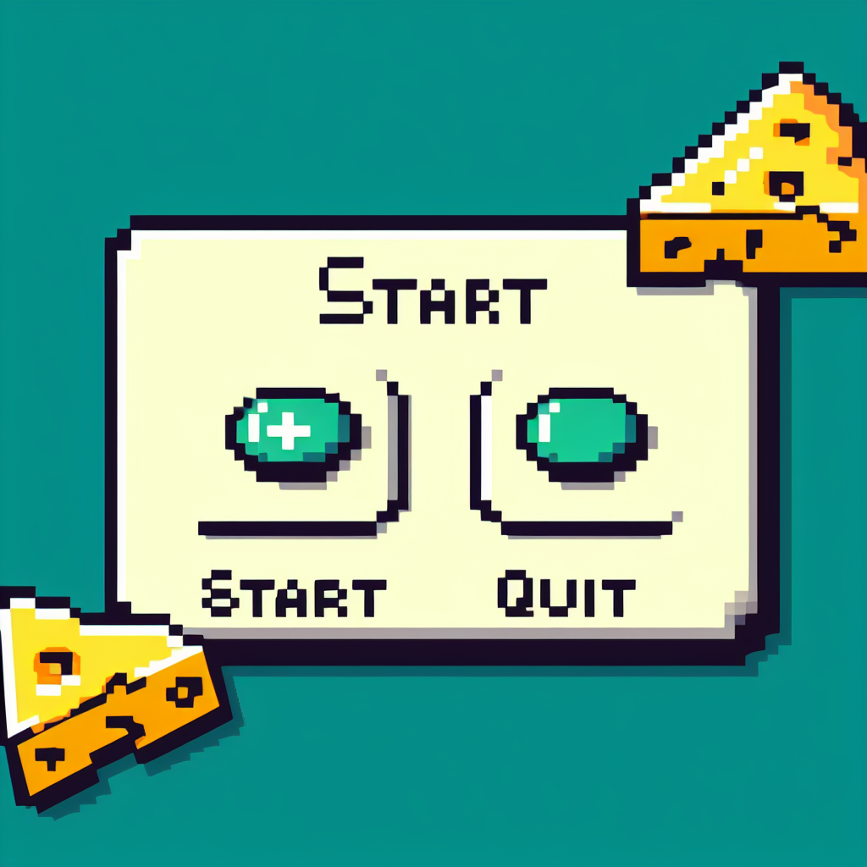

Main Game screen

This is where most of the player’s time will be spent.

In this Screen the player can see the following :

(First level - Nature Breeze)

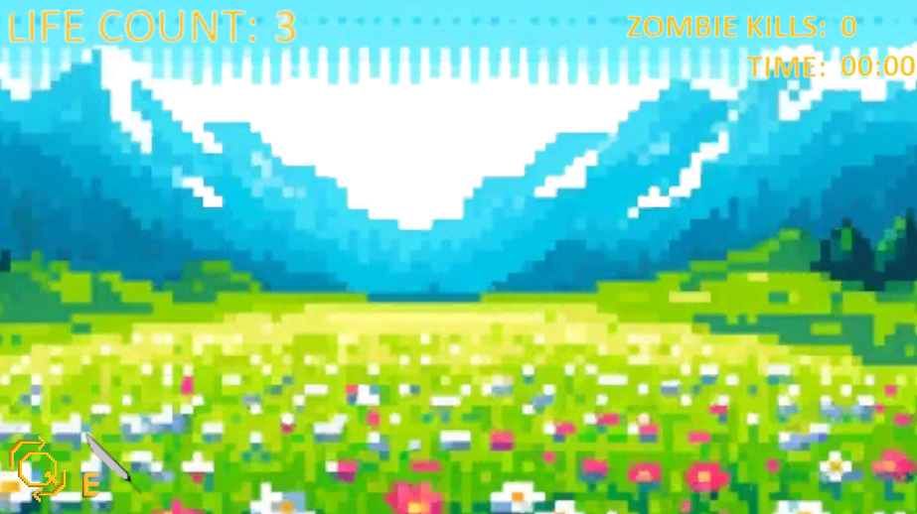

**Swap Icon**

on the bottom left corner of the screen is the Swap Icon, when pressed Q, the icon

will light up for a second indicating the swap between the rats.



To the right of the Swap Icon, the Ability Icon will be shown.

**Ability Icon**

Next to the Swap icon the ability Icon rest and it switches between to icons according to

which rat you are playing. A blade icon for Slice and a shield for Dice. When pressed E,

the icon will light up and then go down by the cooldown set on this ability.

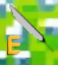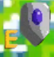

**Zombie kill count & Time**

On the top right corner of the screen, a Time counter that shows how much time has gone by since the player started the level and how many zombie cats he killed.

Both starts with zeros

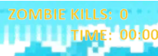

**LIFE COUNTER**

On the top left corner of the screen the amount of lifes the player has on the current

level displays. when the counter reaches Zero the player will go to the

Game Over Screen.



Upgrade/Level end Screen

The player reaches this screen every end of a level and gets to update Slice and Dice

weapons according to the button he Left Mouse clicked on and if he has enough

The weapons upgrade costs 1000 final score points and each level the cost grows.

If the player tries to press one of the two upgrades buttons

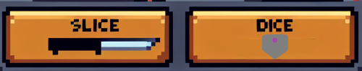

without enough Final score

points they will simply turn red.

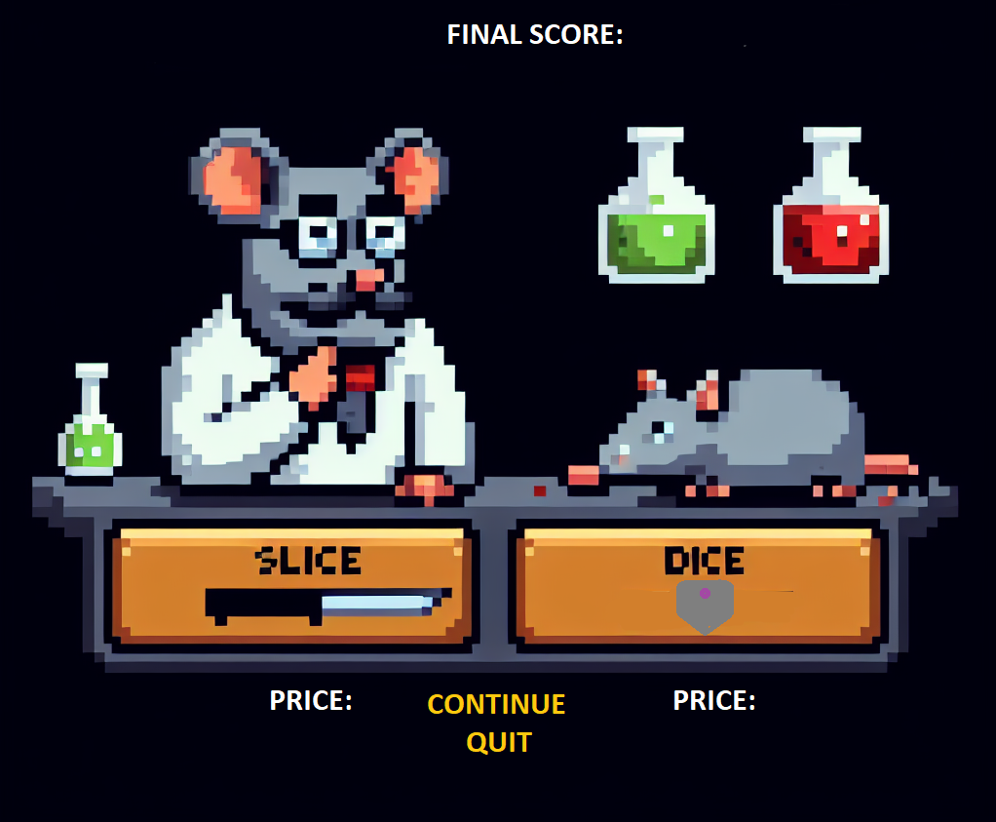

There are also two separate buttons on this screen. Quit which quits the game and the

Continue Button - When pressed, the player will continue to the next level.

Pause Menu

This Menu will show up when the player Pauses mid game by pressing the ESC button

`

Resume Button - Returns to the Point you paused in the game screen.

Quit button - Quits the game.

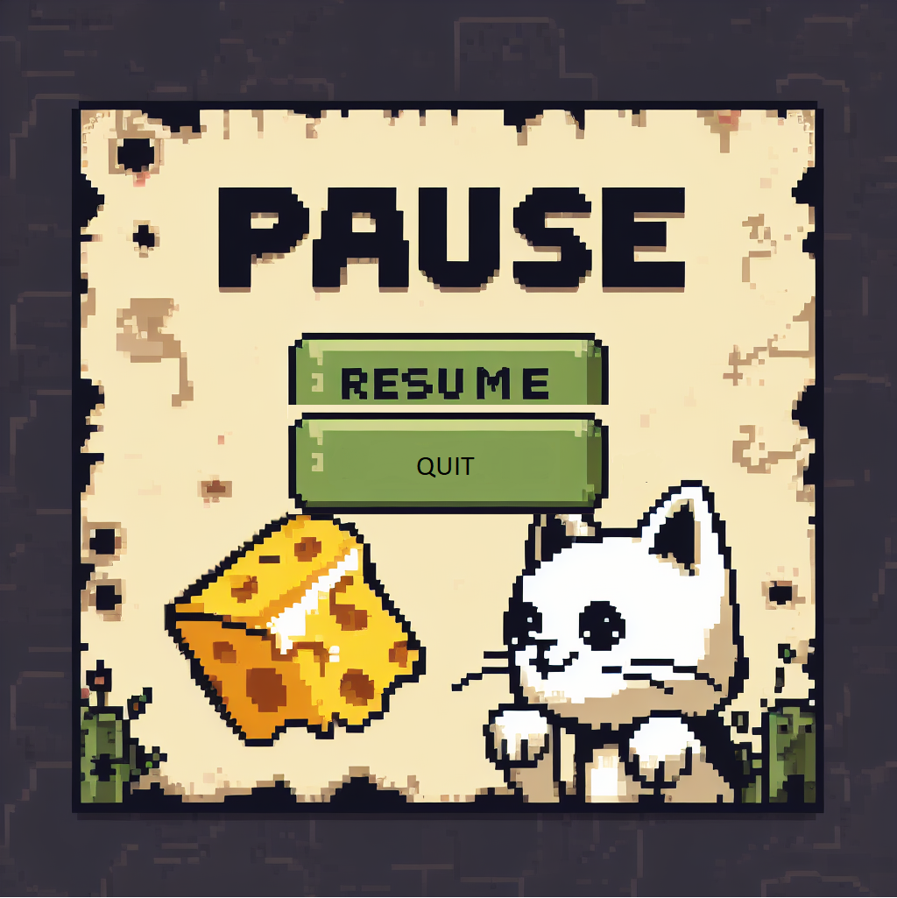

Game Over Screen

The player reaches this screen when he loses all his 3 lifes

Resume Button - Returns to the Point you paused in the game screen.

Quit button - Quits the game.

